## Agenda for Third Meeting

|  |  |  |  |  |
| --- | --- | --- | --- | --- |
|  | | | | |
| **Skyward Federal**  **COPS Platform** | | **1/30/2020**  **1:00 PM to 2:00 PM**  [**https://meet.google.com/ecp-fedi-fbo**](https://meet.google.com/ecp-fedi-fbo)  **NCSU – EB2-2253** | | |
|  | | | | |
|  | | | | |
| Type of meeting: | Project Requirements and Design | Note Taker:  Facilitator: | Jonathan Balliet  Jeen Shaji | |
|  | | | | |
|  | | | | |
| Invitees: | Jonathan Balliet, Jeen Shaji, Daniel Mills, Caleb Boswell, Spencer Yoder, Erin Kotlyn, Danny Caudill, Ryan Carr | | | |
| Please read:  Meeting info: | Questions Below  <https://meet.google.com/ecp-fedi-fbo> | | | |
| **Agenda** | | | | |
|  | | | | |
| Agenda Overview | | All | | 5 min |
| GitLab/Jenkins Discussion | | All | | 30 min. |
| Requirements/Design Overview | | All | | 20 min. |
| Action Items & Next Meeting | | All | | 5 min. |
|  | | | | |
| **Additional Information** | | | | |
|  | | | | |
| Resource persons: | Dr. Jason King, Ms. Margaret Heil, Mr. Richard Kaufman, Erin Kotlyn, Danny Caudill, Ryan Carr | | | |

**COPS Platform Questions**

**Requirements/Design**

Requirements: <https://docs.google.com/document/d/1Ccvz7wOBsk3VC3LaWDXpd4Er7gSOqWrZgNiQ8tX9rDc/edit?usp=sharing>

Use cases: <https://docs.google.com/document/d/1VzZvBA5U6CiHSOjMWXCXSyGSFVeGUZc-Wy7OFuGkb_M/edit>

* Security levels are implied by the user and the request
* Access request not needed for our scope - we should eliminate
* Focus on the Container Runtime and Data Storage use cases

Schema:

<https://drive.google.com/drive/u/0/folders/1bWYqiGNYOT-eo6KpCXfFViw1PmT8W1Xr>

* Set label - how you interact with security system catalog
* Logged in as user or service account - se-linux provides stop gates for this

Sequence Diagram:

<https://drive.google.com/drive/u/0/folders/1bWYqiGNYOT-eo6KpCXfFViw1PmT8W1Xr>

* Data might not be labeled
* Container started with user’s labels

Top-Level Design:

<https://drive.google.com/drive/u/0/folders/1bWYqiGNYOT-eo6KpCXfFViw1PmT8W1Xr>

* Change response and labeled data to same arrow
* Tls handles the encryption, proof of concept with fake data

**Access**

1. When can we expect to have access to Jira and Confluence? - Jeen

* Still in progress
* Answer by tomorrow

1. How can we access the Bastion computer? Is it through AWS now? - Daniel

* .ssh/config
* S3 bucket has this key to access Bastion
* Local ssh ncsu-gitlab does both steps for you to get access to instance

1. After looking through some documentation for SELinux and SE-Postgres, I am having trouble understanding how security contexts are handled. Can we get a short summary of how this works? - Spencer

* Pick two security levels and two categories to do test cases
* s0, s1 and c1 and c2
* Once you have configured for simple case more complicated cases should work

**COPs Overview**:

1. Are we still responsible for this part of the project description: “Students will automate a process to pull data from three different sources, label the data, and write it to the database”?

* Yes, we will label this ourselves

1. Figure 4: Can you explain this diagram in more detail?
   1. 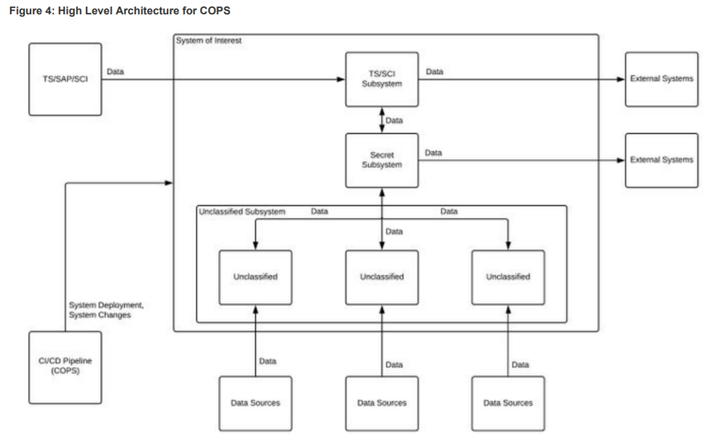

* Not answered

**Container Runtime** ( Docker Container/Firecracker )

1. For the services we are mocking, are we just creating REST endpoints for handling reading and writing of the data right now?

* We have options: web service drop inside container and uses Postgres
* Web interface - we can create ourselves, however we want

1. Are there any restrictions on how we create this RESTful service on the Container? For example, what languages/technologies we can use for implementing this? - Jonathan
   1. We can decide ourselves: Javascript or python
2. Does the consumer ever need to re-authorize when requesting services? Or is only the initial authentication and authorization of this consumer required for a session? - Jonathan
   1. Not needed for our current scope but it is in the overall goal of this system.
   2. The Service itself might eventually be in charge of this
3. It’s mentioned that both the Data Storage and Container Runtime will be on the same CentOs 7 host. Will we be using an EC2 instance for doing this on AWS? - Jonathan

* Yes, this is correct

**Third Sponsor Meeting Minutes**

**Team**: Skyward Federal – MLS API Part 1 **Date**: January 31, 2020

**Facilitator**: Jeen Shaji **Recorder**: Jonathan Balliet

**Attendance**:

* Spencer Yoder
* Jeen Shaji
* Jonathan Balliet
* Daniel Mills
* Caleb Boswell
* Dr. Jason King
* Ms. Margaret Heil
* Erin Kotlyn
* Danny Caudill
* Matthew Peters

**Minutes:**

|  |  |  |
| --- | --- | --- |
| **Action Item** | **Person Responsible** | **Due Date** |
|  |  |  |
|  |  |  |
|  |  |  |
|  |  |  |
|  |  |  |
|  |  |  |
|  |  |  |

**Meeting Evaluation:**

* **Positive -**
* **Negative -**

**Next Meeting:**

* Focus on use cases for Container Runtime and Data Storage

Gitlab:

* + get a ssh key inside ./ssh
  + id_rsa.pub
  + paste in key on gitlab
  + then can clone repo
  + maintainer = allowed to create new projects within group but cant delete
  + all lower cases with dashes for project name is preferred
  + pick internal as privacy level
  + they need to set up proxy properly so we can get to git
  + key-gen question:
  + we are getting a VM for them?
  + Yes, we will generate a key from there. VMs will be set up in AWS.

Jenkins:

* Login in the same way as Gitlab using KeyCloak
* Jenkins will eventually communicate with Gitlab
* Using Jenkins static files for build and deploy

AWS:

* Instance - VM will be a specific OS image
* Proxy accesses both internet and internal network, you
* Be wary of costs
* Terminate - delete harddrive
* Stop - Stop running instance (Stop instances at night when not in use!)

Bastion:

* SSh to bastion and then into your development environment

Hardening an image:

* Make it harder for adversary to break into
* Security policies to increase security, like firewall rules
* Might have to lower restrictions to get access to certain things